Art on the Underground
Accessibility Information: Vauxhall
Exhibition Title: Labyrinth
Artist: Mark Wallinger
Dates: Permanent exhibition
This document has been designed to assist accessibility to and from our exhibition space at Westminster Underground station. If you require any further information or would like to leave feedback about this form, please email us at
art@tube.tfl.gov.uk
Or call us on 020 7027 8694 (Mon-Fri).
Before you start your journey please visit the following links to assist your visit.
See the Current Project Map for station locations for our exhibitions
Weekend closures informs you of weekend closures across the London Underground network.
TFL Journey planner helps you plan your route, from your street to your destination
Travelling by Tube gives useful information and links to help to plan your journey
Accessible Tube maps
Direct Enquiries offers detailed information on access to individual stations, including walking distances between platforms
For further assistance contact London Underground - please contact the Customer Service Centre on 0845 330 9880 (08:00-20:00, seven days a week)
Post: Customer Service Centre, London Underground, 55 Broadway, London SW1H 0BD

Getting to Vauxhall:
South Lambeth Road
London
SW8 1SS

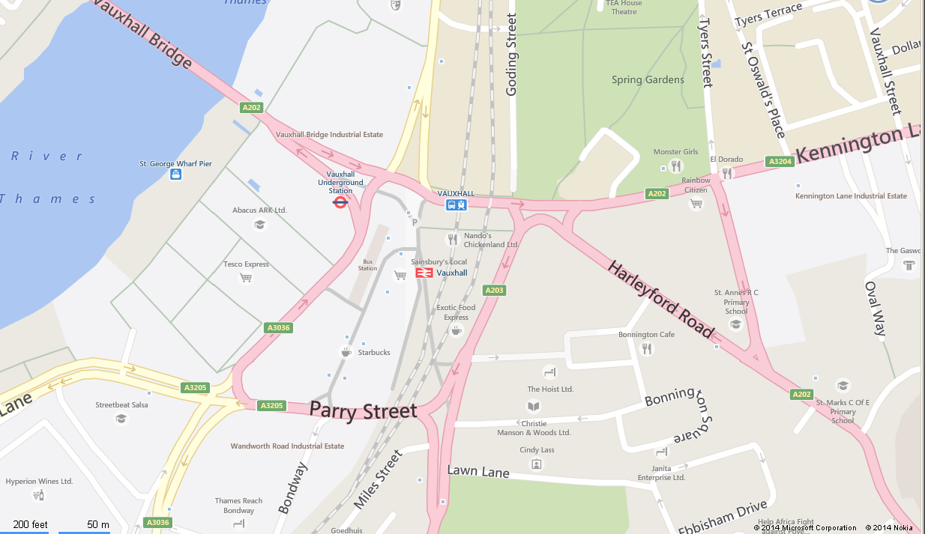

Bus Stops
For more information about bus routes in the area please see the TfL bus maps webpage at: http://www.tfl.gov.uk/tfl/gettingaround/maps/buses/
Taxi Rank
There is no designated taxi rank for this station
Drop Off Point
There is no designated drop off point for this station
Parking
There is no parking facility at this station

Bicycles
There is storage space for bicycles at this station

Approach to the station
The approach to the station is good. Please be aware stations can get very buys during rush hour and is located by a main road.

Accessibility of the exhibition from the trains
Vauxhall is on the Victoria Line.

Seating
There is no seating at this station

Exhibition Space
The art work is located inside the ticket barriers, on the right hand side, on wooden panelling.
If you are unable to locate the exhibition please ask a member of staff or locate a help point.
All persons who wish to see the exhibition must possess a valid travelling ticket, or purchase a ‘platform ticket’ from the ticket office. Platform tickets will allow access to the station and exhibition space for a short period of time, but will not allow train journeys to be made.
In the station the light is artificial.

The steps are identified by a tactile paving, but there is a little tonal contrast which may also create a difficulty for people who are visually impaired.
If you require any assistance or information, station staff will be located in the station at all times. The assistance point, offering information from members of staff, is located on the main ticket hall.
To avoid busy periods please be aware that weekday peak times are around 7am-9.30am and 4.30pm-7pm. At weekends there are no peak times. There may be line closures. TfL have a website dedicated to information about weekend closures at: http://www.tfl.gov.uk/tfl/livetravelnews/realtime/track.aspx?offset=weekend

The artwork: Labyrinth
Artist: Mark Wallinger
The artwork consists of square panel in vitreous enamel, a material used for signs throughout London Underground. Each one bears its own unique circular labyrinth, but with a graphic language common to all. The tactile quality of the artwork’s surface invites the viewer to trace the route with a finger, and to understand the labyrinth as a single meandering path into the centre and back out again – a route reminiscent of the Tube traveller’s journey.
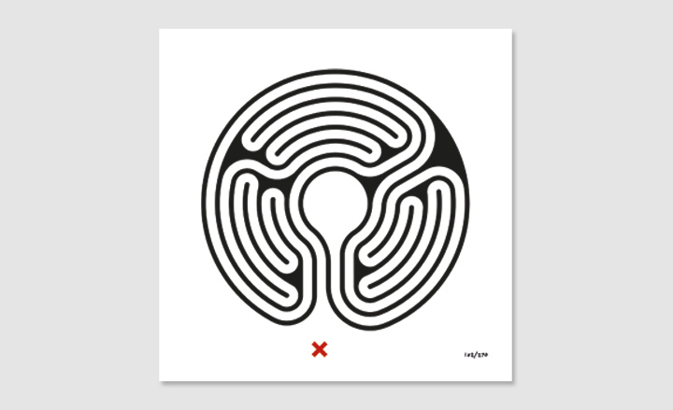

Visit our website art.tfl.gov.uk for further information on the exhibition
To request a transcription of the film or Braille information about the work please contact us at:
Email art@tube.tfl.gov.uk
Call 020 7027 8694 (Mon-Fri)

Toilets
There are no toilets at this station.
Fire Safety
Any safety messages will be voiced over the tannoy system. Please follow any instructions given.
Enjoy your visit and leave a comment online at http://art.tfl.gov.uk/reviews_opinions/comment/

