
Art on the Underground
Station Access : Greenford Station
Greenford Underground station 2011
Project Title: Labyrinth
Artist: Mark Wallinger
Dates: Permanent Instillation
This document has been designed to assist accessibility to and from our project space at Greenford Underground station. If you require any further information or would like to leave feedback about this form, please email us at art@tube.tfl.gov.uk
Or call us on 020 7027 8694 (09:00-17:00, Mon- Fri).
Before you start your journey please visit the following links to assist your visit.
See the Current Project Map for station locations for our projects.
Weekend closures informs you of the closures taking place over the weekend.
TFL Journey Planner helps you plan your route, from your street to your destination.
Travelling by Tube gives useful information and links to help you plan your journey.
Accessible Tube Maps: a range of guides in alternative formats are available to help you plan and make journeys. Please visit: https://www.tfl.gov.uk/tfl/gettingaround/accessibility-guides/default.aspx for more information.
Direct Enquiries offers detailed information on access to individual stations, including walking distances between platforms.
For further assistance contact London Underground- please contact the Customer Service Centre on 0843 222 1234 (24 hours a day).
Post: Customer Service Centre, London Underground, 55 Broadway, London SW1H 0BD.

Getting to Greenford Underground station
Greenford Underground station is located on:
Oldfield Lane
Greenford
Middx
UB6 8PX
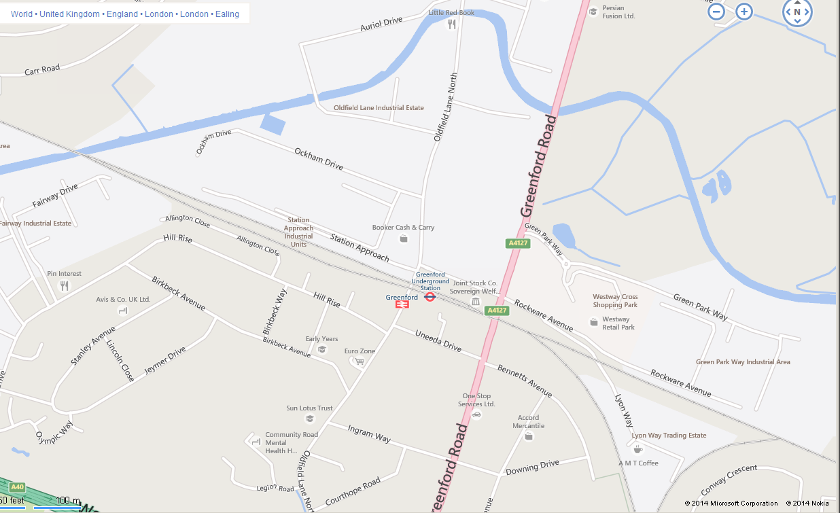

Bus stops
Bus stops are located by Rockware Avenue.
For more information about the bus routes in the area please see the TFL bus maps webpage at http://www.tfl.gov.uk/tfl/gettingaround/maps/buses
Taxi Rank
There is no taxi rank for Greenford station. A taxi kiosk can be found inside the ticket hall of the Underground station.
Drop Off Point
The drop off point is directly outside of the Tube station.

Bike racks
Bike racks are available inside the station.
Parking
A public car park is available just by the side of the Underground station.
Best time to visit
To avoid busy periods please be aware that weekday peak times are around 7am- 9.30am and 4pm-7pm. At weekends there are no peak times. Line closures regularly occur during the weekend; Tube users are advised to check the TFL website http://www.tfl.gov.uk/ for the latest travel news on line closures.
If you require any assistance or information, station staff will be located in the station at all times. Help points are located on train platforms and the main ticket hall.
Approach to the station
There is only one entrance to the Tube station.
Not all the crossings are controlled by traffic lights. However they are designed in accordance with contemporary guidance; highlighted red dropped kerbs and tactile paving.
There is no seating in this area.
Accessibility of the project from the trains
Greenford Underground station connects to the Central line and Network Rail.
Seating
Each platform on all lines has seating within every 50 metres along the platform

Artist: Mark Wallinger
Mark Wallinger, one of the UK’s leading contemporary artists, has created a major new artwork for London Underground to celebrate its 150th anniversary. Wishing to forge a poetic link with the Tube’s rich history of graphic language, he has made a work that sits comfortably alongside the two of its major design icons, the roundel and Harry Beck’s Tube map, and yet stands out as a new symbol marking the Tube’s 150th year.
Wallinger explores a diverse range of subjects in his practice, from the historic and mythic to the biographical and contemporary, resulting in works that are layered with rich cultural references for the viewer to discover.
Wallinger’s personal relationship with the Underground has informed his interest in public transport and fuelled a fascination with the idea of being ‘transported’ in an imaginative or spiritual sense. This idea gave rise to the ancient symbol that lies at the heart of this commission: the labyrinth, which represents this idea of the spiritual journey in many different traditions across the globe. For Wallinger, the labyrinth is a fitting analogy for the millions of journeys that are made across the Tube network every day.
Wallinger has created 270 individual artworks, one for each station on the network, each one bearing its own unique circular labyrinth, but with a graphic language common to all. Rendered in bold black, white and red graphics, the artworks are produced in vitreous enamel, a material used for signs throughout London Underground, including the Tube’s roundel logo, whose circular nature the labyrinth design also echoes. Positioned at the entrance of each labyrinth is a red X. This simple mark, drawing on the language of maps, is a cue to enter the pathway. The tactile quality of the artwork’s surface invites the viewer to trace the route with a finger, and to understand the labyrinth as a single meandering path into the centre and back out again – a route reminiscent of the Tube traveller’s journey.

Toilets
There are no toilets inside the station
Fire Safety
Any safety messages will be voiced over the tannoy system. Please follow any instructions give.
Enjoy your visit and leave a comment online at http://art.tfl.gov.uk/reviews_opinions/comment/

